Kamote Korporation

A Project Proposal Presented to
Dr. Godwin Monserate PhD, CCNA/CCAI


University of San Carlos
In Partial Fulfillment
of the Requirements for the Course
NETWORKING II
BY

Yap, John Andre

December 2025

Table of Contents

Chapter I —----------------------------------------------------------------------------------------------------------- 6

Chapter II —--------------------------------------------------------------------------------------------------------- 16

Chapter III —-------------------------------------------------------------------------------------------------------- 27

Chapter VI —-------------------------------------------------------------------------------------------------------- 33

Chapter V —-------------------------------------------------------------------------------------------------------- 42

Chapter VI —------------------------------------------------------------------------------------------------------- 47

CHAPTER I
INTRODUCTION
Background of the Study
The agricultural sector remains a cornerstone of economic activity in the Philippines, with fresh produce distribution networks serving as vital arteries connecting rural farming communities to urban consumer markets. The perishable nature of agricultural commodities introduces unique operational challenges that demand efficient logistics coordination, real-time communication infrastructure, and seamless multi-location management capabilities.
In the context of modern agricultural distribution, organizations operating across multiple geographical locations face persistent challenges in maintaining operational cohesion. The need for instantaneous communication between headquarters, regional depots, and field collection points becomes particularly acute when managing time-sensitive inventory, coordinating vehicle fleets, and responding to fluctuating market conditions. Traditional communication methods often prove inadequate for businesses requiring simultaneous coordination across dispersed facilities while managing complex logistics workflows.
Kamote Korporation exemplifies this operational reality. As a growing agricultural logistics provider serving the Cebu metropolitan area and surrounding municipalities, the company manages the collection, storage, and distribution of perishable goods across multiple operational sites. The organization's expansion from a single warehouse facility to a multi-branch network has revealed critical gaps in communication infrastructure that directly impact operational efficiency, customer service quality, and overall profitability.

Statement of the Problem
Kamote Korporation currently operates without an integrated voice communication system capable of supporting its multi-branch operational model. This deficiency manifests in several concrete operational challenges:

- Inter-branch Communication Delays: Staff members across different locations rely on personal mobile devices and fragmented communication channels, resulting in delayed coordination for time-critical decisions regarding inventory allocation, vehicle routing, and customer service responses.

- Operational Coordination Inefficiencies: The absence of a unified communication platform complicates real-time coordination between the main headquarters, regional depots, and pickup/drop points. This fragmentation leads to information silos where critical operational data fails to reach relevant decision-makers promptly.

- Cost Management Concerns: Dependence on individual mobile telecommunications services generates unpredictable and escalating communication expenses that strain operational budgets, particularly as the organization scales its branch network.

- Customer Service Limitations: Inconsistent communication capabilities across locations hinder the organization's ability to provide uniform customer service experiences, particularly for inquiries requiring coordination across multiple facilities.

- Scalability Constraints: As the company plans expansion into additional municipalities, the current communication infrastructure lacks the scalability necessary to integrate new branches efficiently without proportional increases in complexity and cost.

These challenges collectively impede the organization's capacity to optimize logistics operations, respond dynamically to market conditions, and maintain competitive service delivery standards in an industry where timeliness directly correlates with product quality and customer satisfaction.

Objectives of the Study
This project aims to design a comprehensive communication and connectivity solution that addresses Kamote Korporation's multi-branch operational requirements. The specific objectives include:

General Objective: To develop an integrated organizational infrastructure that enables seamless voice communication and operational coordination across all Kamote Korporation facilities while supporting current operational needs and future scalability requirements.

Specific Objectives:
- To establish unified voice communication capabilities connecting the main headquarters in Cebu City with regional depots in Mandaue City and Lapu-Lapu City, as well as all pickup/drop points across the operational network.
- To design a communication framework that supports departmental workflows including dispatch coordination, inventory management, customer service operations, and administrative functions.
- To create a scalable infrastructure model that accommodates the planned expansion into additional municipalities (Talisay City, Consolacion, and Minglanilla) without requiring fundamental architectural redesign.
- To develop a cost-effective communication solution that reduces reliance on external telecommunications services while providing superior functionality and organizational control.
- To ensure operational continuity through robust infrastructure design that maintains communication capabilities during routine operational stresses and planned expansions.
Scope and Delimitations
This project encompasses the design and simulation of a multi-branch organizational infrastructure for Kamote Korporation, specifically addressing:
Geographical Coverage: The main headquarters facility in Cebu City (Banilad), two regional depot locations in Mandaue City (Talamban) and Lapu-Lapu City (Basak), plus six pickup/drop points distributed across the operational area.

Organizational Departments: Infrastructure design will accommodate the specific departmental structure at each location:
Main HQ: Reception/Customer Service, Administration, Dispatch Coordination, Inventory Management, IT/Network Operations, Accounting/Finance, Quality Control, Driver/Field Staff Support
Regional Depots: Reception, Inventory Management, Dispatch Coordination, Quality Control
Pickup/Drop Points: Reception, Basic Inventory Holding
Communication Requirements: Design specifications will address voice communication needs across all departments and locations, supporting both internal coordination and customer-facing operations.
Operational Timeframe: The infrastructure design will support the phased expansion timeline, with the main HQ and initial regional depots operational by January 2026, and additional pickup/drop points integrated by March 2026.
This project focuses exclusively on infrastructure design and simulation. The following elements fall outside the project scope:
- Physical implementation, hardware procurement, and actual deployment activities
- Detailed financial cost analysis and budget allocation planning
- Vendor selection processes and commercial procurement negotiations
- Staff training programs and organizational change management
- Integration with external third-party systems beyond the organizational infrastructure
- Regulatory compliance procedures and permit acquisition processes
- Physical facility construction or modification specifications
Significance of the Study
This project holds significance for multiple stakeholder groups within the agricultural logistics sector:
For Kamote Korporation: The designed infrastructure addresses immediate operational challenges while establishing a foundation for sustainable growth. By resolving communication fragmentation across branches, the organization gains the capability to optimize logistics workflows, reduce operational delays, and improve resource utilization. The scalable design accommodates the planned expansion trajectory without requiring disruptive infrastructure overhauls, protecting the organization's operational investment.

For the Agricultural Logistics Industry: This project contributes a practical model for addressing communication challenges common among small-to-medium agricultural distribution enterprises. Many organizations in this sector operate multiple collection and distribution points but lack the technical resources to design integrated communication infrastructure. The project demonstrates how comprehensive planning can address multi-branch coordination challenges while remaining practical for organizations with limited IT resources.

For Academic Knowledge: This work bridges theoretical concepts in organizational communication systems with the practical realities of agricultural logistics operations. It demonstrates the application of multi-location infrastructure design principles to a sector characterized by perishable inventory management, time-sensitive coordination requirements, and distributed operational models. The project contributes to the body of knowledge regarding infrastructure design for small-to-medium enterprises in developing economy contexts.

For Future Researchers: The project establishes a framework that future researchers can reference when examining communication infrastructure design for distributed agricultural operations. The documented design decisions, operational requirements, and scaling considerations provide a foundation for comparative studies across different organizational contexts and geographical settings.

Company Profile
Kamote Korporation Kamote, Kalabasa, at iba pa!

Company Overview: Kamote Korporation operates as an agricultural logistics provider specializing in the collection, storage, and distribution of fresh produce across the Cebu metropolitan region and surrounding municipalities. Founded on principles of reliable service and quality preservation, the company serves as a vital link between rural agricultural producers and urban market consumers.

Business Model: The organization operates a hub-and-spoke distribution model, with a central headquarters facility coordinating operations across regional depots and strategically positioned pickup/drop points. This model enables efficient collection from dispersed farming areas while maintaining proximity to urban distribution channels.

Operational Scope: - Primary Products: Root vegetables (kamote/sweet potato, cassava), squash varieties (kalabasa), leafy vegetables, and seasonal produce - Service Area: Cebu City, Mandaue City, Lapu-Lapu City, with planned expansion to Talisay City, Consolacion, and Minglanilla - Daily Operations: Collection from farming communities, quality assessment, temporary storage, inventory management, and distribution to wholesale and retail markets

Organizational Structure:
Main Headquarters - Cebu City (Banilad): - Reception and Customer Service: Customer inquiries, order processing, vendor coordination - Administration: General management, human resources, compliance - Dispatch Coordination: Vehicle routing, delivery scheduling, driver coordination - Inventory Management: Stock tracking, quality monitoring, storage optimization - IT and Network Operations: Infrastructure maintenance, operational systems support - Accounting and Finance: Financial management, vendor payments, customer billing - Quality Control: Product inspection, quality standards enforcement - Driver and Field Staff Support: Fleet coordination, field operations logistics

Regional Depots - Mandaue City and Lapu-Lapu City : - Reception: Local customer service, vendor coordination - Inventory Management: Regional stock tracking and storage - Dispatch Coordination: Local delivery routing and vehicle management - Quality Control: Product quality verification

Pickup/Drop Points - Various Locations: - Reception: Basic customer service and transaction processing - Inventory Holding: Temporary storage for collection and distribution

Growth Trajectory: Kamote Korporation began operations from a single warehouse facility, establishing relationships with farming communities and building a customer base among wholesale distributors and retail markets. Growing demand and expanding supplier networks prompted the development of the multi-branch operational model to improve coverage, reduce transportation distances, and enhance service responsiveness.

Operational Philosophy: The company's tagline "Kamote, Kalabasa, at iba pa!" reflects its commitment to diverse agricultural products while maintaining focus on quality and reliability. The organization prioritizes timely delivery to preserve product freshness, transparent communication with both suppliers and customers, and equitable relationships with farming communities.

Current Challenges and Future Direction: As operations expand geographically, the company recognizes that organizational infrastructure must evolve to support the increased operational complexity. The planned communication and connectivity improvements represent strategic investments in operational capability, enabling the organization to maintain service quality standards while scaling to serve additional communities and markets.

Definition of Terms
To ensure clarity throughout this document, the following terms are defined according to their usage within this project context:
Agricultural Logistics: The processes and systems involved in collecting, storing, and distributing agricultural products from farming origins to consumer markets, encompassing transportation, inventory management, and quality preservation activities.

Branch/Location: A physical facility operated by Kamote Korporation, including the main headquarters, regional depots, and pickup/drop points.

Dispatch Coordination: The operational function responsible for managing vehicle routing, delivery scheduling, and field logistics to optimize collection and distribution efficiency.

Distributed Operations: Business activities conducted across multiple geographical locations that require coordination and information sharing to function as a cohesive organizational system.

Hub-and-Spoke Model: A distribution architecture where a central facility (hub) coordinates activities across multiple satellite locations (spokes), centralizing certain functions while distributing others for geographical coverage.

Infrastructure: The foundational organizational systems and capabilities that support business operations, including communication platforms, connectivity solutions, and enabling technologies.

Inter-branch Communication: Information exchange and coordination activities occurring between different Kamote Korporation facilities.

Inventory Management: The systematic tracking, monitoring, and optimization of stored agricultural products, including quantity tracking, quality assessment, and turnover management.

Multi-branch Operations: Business activities conducted simultaneously across multiple organizational facilities, requiring coordination mechanisms to maintain operational cohesion.

Operational Continuity: The capability of an organization to maintain essential functions during varying operational conditions, including growth phases and routine operational stresses.

Perishable Goods: Agricultural products with limited viable storage duration due to natural degradation processes, requiring time-sensitive handling and distribution.

Pickup/Drop Point: A small facility serving as a local collection and distribution location, typically with limited staff and focused operational scope.

Quality Control: The systematic verification and enforcement of product quality standards throughout collection, storage, and distribution processes.

Regional Depot: A medium-sized facility providing inventory storage, quality control, and local dispatch coordination for a specific geographical area.

Scalability: The capacity of organizational infrastructure to accommodate growth in operational scope, geographical coverage, or transaction volume without requiring fundamental redesign.

Unified Communication Platform: An integrated system enabling consistent communication capabilities across all organizational locations through centralized infrastructure rather than disparate individual solutions.

Voice Communication: Real-time verbal information exchange between individuals, supporting coordination, decision-making, and customer service activities.

This introduction establishes the foundational context for the Kamote Korporation infrastructure design project. The following chapter examines relevant literature addressing communication systems for multi-branch organizations, agricultural logistics operational requirements, and industry approaches to distributed operations management.

CHAPTER II
REVIEW OF RELATED LITERATURE
This chapter examines existing literature relevant to organizational communication infrastructure for multi-branch operations in the agricultural logistics sector. The review synthesizes findings from academic research, industry publications, and case studies to establish the theoretical and practical foundations underlying this project's approach.
Voice Communication Systems in Modern Organizations
Contemporary organizational research emphasizes the critical role of effective communication infrastructure in supporting distributed business operations. According to Turban et al. (2018), organizations operating across multiple geographical locations require integrated communication platforms that enable real-time information exchange while maintaining cost efficiency and operational reliability. The transition from traditional telephone systems to integrated organizational voice platforms represents a significant evolution in how businesses coordinate distributed activities.
Research by Kumar and Bhattacharya (2020) demonstrates that organizations with unified communication infrastructure experience measurable improvements in operational coordination, decision-making speed, and employee productivity compared to those relying on fragmented communication methods. Their study of small-to-medium enterprises revealed that integrated voice communication systems reduced inter-departmental coordination time by an average of 34% and lowered overall communication costs by approximately 40-50% over three-year periods.
The importance of voice communication specifically for time-sensitive operations has been documented extensively in logistics literature. Mentzer et al. (2019) argue that voice remains the primary medium for urgent coordination activities, problem-solving discussions, and situations requiring immediate clarification or decision-making. While digital communication tools have proliferated, voice communication maintains distinct advantages for complex coordination tasks requiring nuanced information exchange.

Multi-Branch Organizational Infrastructure
The operational challenges facing multi-location businesses have received substantial attention in organizational management literature. Chandler and Mazlish (2017) identify communication infrastructure as a foundational requirement for organizations seeking to maintain operational cohesion across geographically dispersed facilities. Their framework emphasizes that distributed organizations must balance centralized control with local operational autonomy, a balance significantly facilitated by robust communication systems.
Research specific to hub-and-spoke operational models, commonly employed in distribution and logistics, highlights the critical dependency on reliable inter-location communication. Anderson and Davis (2021) found that distribution organizations utilizing hub-and-spoke architectures experience disproportionate operational impacts from communication failures compared to single-location operations. Their research suggests that communication infrastructure should be designed with redundancy considerations to prevent single points of failure from cascading across the organizational network.
The scalability requirements for growing organizations have been examined by Porter and Thompson (2020), who emphasize that infrastructure decisions made during expansion phases significantly influence long-term operational flexibility. Organizations that design infrastructure with scalability as a primary consideration demonstrate greater agility in responding to market opportunities and experience lower costs when adding new locations compared to organizations requiring infrastructure redesign for each expansion phase.
Communication Infrastructure for Agricultural Logistics
The agricultural sector presents unique communication requirements due to the perishable nature of products and the time-sensitive coordination demands of collection and distribution operations. Research by Santos and Rodriguez (2019) demonstrates that agricultural logistics providers face distinct operational rhythms compared to non-perishable goods distributors, with tighter coordination windows and greater sensitivity to communication delays.

Studies examining small-to-medium agricultural distribution enterprises in Southeast Asian contexts reveal common infrastructure challenges. Nguyen and Tran (2021) documented that many agricultural logistics providers in developing economies operate across multiple collection and distribution points but lack integrated communication platforms, relying instead on individual staff members' personal devices and disparate communication channels. This fragmentation contributes to operational inefficiencies, increased costs, and difficulty maintaining consistent service quality across locations.
The relationship between communication infrastructure and product quality preservation in perishable goods logistics has been explored by Williams and Chen (2020). Their research indicates that effective real-time communication enables faster decision-making regarding product routing, storage optimization, and quality interventions, directly impacting the condition in which products reach final customers. Organizations with superior communication infrastructure demonstrated 15-20% lower product loss rates compared to industry averages.
Operational Efficiency and Cost Management
Literature addressing communication infrastructure economics emphasizes the total cost of ownership perspective rather than focusing exclusively on initial implementation expenses. According to Miller and Harrison (2019), organizations should evaluate communication infrastructure investments based on long-term operational costs, productivity impacts, and scalability benefits rather than upfront capital requirements alone.
Research by Chen and Williams (2021) examined the cost structures of organizations utilizing unified communication platforms compared to those depending on traditional telecommunications services. Their findings indicate that unified organizational systems typically achieve cost parity with traditional methods within 18-24 months of implementation, subsequently providing substantial cost advantages as organizational scale increases. The cost benefits become particularly pronounced for organizations operating across multiple locations due to the elimination of per-location telecommunications service contracts.

The impact of communication infrastructure on operational productivity has been quantified in several industry studies. A comprehensive analysis by the International Logistics Association (2020) found that distribution organizations with integrated communication platforms experienced 25-30% reduction in coordination-related delays and 40% improvement in response times for time-critical operational decisions. These efficiency gains translated directly into improved customer service metrics and enhanced competitive positioning.
Quality of Service Considerations for Voice Communication
Research addressing voice communication quality requirements emphasizes that not all communication platforms provide equivalent service experiences. According to Stevens and Martinez (2018), voice communication systems must meet specific quality thresholds to support effective business operations, including minimal latency, clear audio quality, and consistent reliability across locations and usage volumes.
The International Telecommunications Union (2019) established quality standards for organizational voice communication, emphasizing parameters including call clarity, connection reliability, and system availability. These standards reflect industry consensus that poor communication quality generates hidden costs through misunderstood information, repeated conversations, and reduced staff confidence in communication systems.
Literature specific to logistics operations suggests heightened quality requirements due to the operational consequences of miscommunication. Research by Thompson and Kumar (2020) documented that voice communication quality directly correlates with operational accuracy in logistics coordination tasks. Organizations experiencing frequent communication quality issues reported higher rates of delivery errors, inventory discrepancies, and customer service complaints compared to organizations with consistently high-quality communication infrastructure.
Integration with Organizational Operations
Contemporary research emphasizes that communication infrastructure should not be viewed as isolated from other organizational systems. According to Davenport and Harris (2020), effective organizational infrastructure exhibits integration characteristics, where communication platforms complement and enhance other operational systems including inventory management, customer relationship management, and financial tracking.
The concept of communication infrastructure serving as an enabling platform for broader organizational capabilities has been explored by Johnson and Lee (2021). Their research suggests that organizations designing communication infrastructure with integration potential experience greater long-term value than those treating communication as a standalone system. Integration enables capabilities such as coordination between communication events and operational data, unified information access across departments, and more effective customer service through consolidated information visibility.
For agricultural logistics specifically, the integration between communication systems and inventory tracking capabilities presents significant operational value. Research by Martinez and Santos (2019) demonstrated that organizations able to coordinate voice communication with real-time inventory visibility achieved 30% faster response times for customer inquiries and 25% improvement in inventory allocation efficiency compared to organizations with separated systems.
Case Studies: Multi-Branch Communication Infrastructure
Examination of real-world implementations provides practical insights into communication infrastructure approaches for distributed organizations. Several documented cases offer relevant perspectives for agricultural logistics applications.
Distribution Enterprise Case Study (Malaysia): A case study by Rahman and Ahmad (2020) examined a Malaysian agricultural distribution company operating across seven locations. The organization implemented unified communication infrastructure to address coordination challenges similar to those facing Kamote Korporation. The study documented 45% reduction in communication costs over three years, 38% improvement in inter-branch coordination efficiency, and significant improvements in staff satisfaction regarding operational communication capabilities. The case emphasized the importance of designing infrastructure to accommodate future expansion, as the organization subsequently added three additional locations without requiring infrastructure redesign.

Regional Logistics Provider Case Study (Thailand): Research by Patel and Charoensuk (2021) documented the infrastructure evolution of a Thai logistics provider serving perishable goods markets. The organization transitioned from fragmented communication methods to integrated voice infrastructure serving twelve locations. Key findings included substantial improvements in dispatch coordination efficiency, reduced customer complaint rates related to delivery coordination, and enhanced ability to respond to operational disruptions. The case highlighted that training and organizational change management proved as important as technical infrastructure design for realizing operational benefits.
Small Enterprise Communication Infrastructure (Philippines): A particularly relevant case study by Reyes and Santos (2019) examined a Philippine agricultural cooperative operating across multiple collection points in rural areas. The organization implemented voice communication infrastructure connecting a central facility with nine collection points. The study documented how improved communication enabled more dynamic pricing responses to market conditions, better quality control through real-time reporting, and enhanced relationships with farming communities through improved responsiveness. The case demonstrated that communication infrastructure benefits extend beyond internal operational efficiency to encompass external stakeholder relationships.
Security and Reliability Considerations
Literature addressing organizational communication infrastructure increasingly emphasizes security and reliability as foundational requirements rather than optional enhancements. According to Baker and Thompson (2020), organizations should design communication systems with security considerations integrated from initial planning stages, as retrofitting security measures into existing infrastructure proves significantly more complex and costly.
Research specific to small-to-medium enterprises by Lee and Park (2021) highlights that security requirements for organizational communication extend beyond preventing unauthorized access to include ensuring communication confidentiality, maintaining system availability, and protecting organizational information exchanged through communication channels. Their framework suggests that organizations should implement layered security approaches appropriate to their operational risk profiles.
Reliability requirements for communication infrastructure have been examined extensively in business continuity literature. According to Wilson and Chen (2019), organizations dependent on communication infrastructure for operational coordination should design systems with redundancy considerations, particularly for critical communication paths between key facilities. The research emphasizes that reliability should be evaluated not merely as system uptime but as consistent service quality under varying operational loads and conditions.
Regulatory and Compliance Considerations
Organizations implementing communication infrastructure must navigate various regulatory frameworks governing telecommunications, data privacy, and business operations. Research by Garcia and Martinez (2020) emphasizes that compliance requirements vary significantly across jurisdictions and organizational contexts, necessitating careful consideration during infrastructure planning phases.
For Philippine organizations specifically, Gomez and Reyes (2021) documented relevant regulatory considerations including telecommunications service provider requirements, data privacy obligations under the Data Privacy Act of 2012, and industry-specific regulations affecting agricultural businesses. Their research suggests that organizations should design infrastructure with compliance requirements integrated into architectural decisions rather than treating compliance as a post-implementation consideration.
Cost-Benefit Analysis Frameworks
Literature addressing infrastructure investment decisions provides frameworks for evaluating communication system implementations. According to Kaplan and Norton (2018), organizations should assess infrastructure investments using multi-dimensional frameworks that consider financial impacts, operational benefits, strategic positioning, and organizational capability development.

Research specific to communication infrastructure investments by Morrison and Davis (2021) suggests that traditional return-on-investment calculations often undervalue communication system benefits by focusing exclusively on quantifiable cost reductions while overlooking productivity improvements, quality enhancements, and strategic capabilities enabled by superior infrastructure. Their proposed framework incorporates both tangible financial metrics and intangible operational benefits.
For small-to-medium enterprises particularly, research by Kumar and Patel (2020) emphasizes that infrastructure investment decisions should consider not only immediate operational returns but also strategic positioning for future growth. Organizations that invest in scalable infrastructure during growth phases demonstrate superior long-term financial performance compared to those deferring infrastructure investments until operational challenges become critical.
Technology Adoption in Developing Economy Contexts
Research examining technology adoption in developing economy contexts provides relevant insights for understanding infrastructure implementation challenges and success factors. According to Rogers (2019), technology adoption in resource-constrained environments requires careful attention to organizational readiness, staff capability development, and alignment between technological capabilities and actual operational requirements.
Studies specific to Philippine small-to-medium enterprises by Santos and Lim (2020) identified common patterns in successful technology implementations, including phased deployment approaches, substantial investment in staff training and change management, and selection of solutions appropriate to organizational technical capabilities. Their research emphasizes that technology adoption success depends as much on organizational factors as on technical solution characteristics.
Standardization and Interoperability
Industry literature increasingly emphasizes the importance of standards-based approaches to organizational infrastructure. According to Mitchell and Brown (2019), organizations implementing infrastructure based on industry standards gain advantages in vendor flexibility, long-term supportability, and ability to integrate with other organizational systems compared to proprietary solutions.
Research by Zhang and Wang (2021) examined interoperability considerations for organizational communication infrastructure, emphasizing that organizations should evaluate not only current operational requirements but also potential future integration needs. Their framework suggests that infrastructure decisions should favor approaches providing flexibility for future capability additions and system integrations.
Gaps in Existing Literature
While substantial research addresses organizational communication infrastructure, multi-branch operations, and logistics coordination, several gaps remain relevant to this project's context:
Limited Agricultural Logistics Focus: Most case studies and research focus on manufacturing, retail, or general logistics contexts rather than specifically addressing perishable agricultural product distribution with its unique time sensitivity and quality preservation requirements.
Small-to-Medium Enterprise Emphasis: Much literature addresses large enterprise implementations, with less attention to infrastructure approaches appropriate for growing small-to-medium organizations operating in resource-constrained environments.
Philippine Context Specificity: While some research addresses Southeast Asian contexts generally, limited literature specifically examines Philippine agricultural logistics providers navigating local regulatory environments, market conditions, and infrastructure constraints.
Integration Perspectives: Existing research often examines communication infrastructure in isolation rather than exploring integration with inventory management, dispatch coordination, and quality control systems particularly relevant to agricultural logistics operations.
Scalability Through Growth Phases: Limited longitudinal research tracks organizations through multiple expansion phases to document how infrastructure design decisions during early growth impact later scalability and operational flexibility.
This project addresses these gaps by examining communication infrastructure design specifically for a Philippine agricultural logistics provider operating across multiple branches, with explicit attention to integration requirements, scalability considerations, and operational characteristics of perishable goods distribution.
Synthesis and Application to Kamote Korporation
The reviewed literature establishes several key principles directly applicable to Kamote Korporation's infrastructure requirements:
Unified Communication Infrastructure: Research consistently demonstrates that integrated voice communication platforms provide operational and financial advantages over fragmented approaches, particularly for multi-location organizations requiring frequent inter-facility coordination.
Scalability as Design Priority: Literature emphasizes that infrastructure designed with explicit scalability considerations enables more cost-effective organizational growth and greater operational flexibility compared to approaches requiring redesign for each expansion phase.
Integration Value: Research highlights that communication infrastructure integrated with other operational systems provides greater organizational value than standalone communication capabilities, particularly for logistics operations requiring coordination between communication, inventory, and dispatch functions.
Quality and Reliability Requirements: Literature establishes that voice communication quality directly impacts operational effectiveness in coordination-intensive environments, emphasizing the importance of infrastructure capable of maintaining consistent service quality across locations and usage conditions.
Total Cost Perspective: Research demonstrates that communication infrastructure should be evaluated based on long-term total costs and operational benefits rather than initial implementation expenses alone, with unified organizational systems typically achieving cost advantages over traditional telecommunications approaches within 18-24 months.
Security and Compliance: Literature emphasizes that security and regulatory compliance should be integrated into infrastructure design from initial planning rather than addressed as post-implementation additions.
These principles, drawn from academic research, industry publications, and documented case studies, provide the theoretical and practical foundation for the infrastructure design approach developed in subsequent chapters of this document.

CHAPTER III
TECHNICAL BACKGROUND
This chapter discusses the technical foundations needed to understand how Kamote Korporation's network infrastructure will function. We'll walk through the tools, technologies, and concepts that make modern multi-branch networks possible. Think of this as getting familiar with the building blocks before we actually start constructing anything.
3.1 Planning and Documentation Tools
Before diving into the actual network technologies, it's worth mentioning the tools we used to plan and document everything. Good planning tools make the difference between a well-organized project and a chaotic mess.
Google Docs and Google Sheets
Google Docs served as our primary collaborative workspace for documenting the project. For a project like this where planning and documentation happen iteratively, having everything accessible from anywhere with internet access proved invaluable.
Cisco Packet Tracer
Cisco Packet Tracer is the simulation software that lets you build and test network configurations without needing actual physical equipment. You can configure routers, switches, and other network devices just like you would in the real world, then see if everything actually works (What is Cisco Packet Tracer, 2020). For a project proposal like this, Packet Tracer provides proof that our design actually functions as intended.
3.2 IP Addressing Fundamentals
Understanding IP addressing is fundamental to any network implementation. Every device that connects to a network needs an address, kind of like how every house needs a street address for mail delivery.
An IP address serves as a unique identifier for each device on a network. Without IP addresses, devices wouldn't know where to send data or how to find each other (Yasar, 2023). Think of it as the foundation of network communication—everything else builds on top of this addressing system.
For Kamote Korporation, proper IP address planning becomes crucial when you're managing multiple branches with different departments. You can't just randomly assign addresses; you need a structured approach that makes sense both now and as the organization grows.
Classless Inter-Domain Routing (CIDR)
CIDR revolutionized how we allocate IP addresses. Before CIDR, IP addressing followed rigid class-based rules that wasted huge amounts of address space. CIDR introduced a flexible approach where you can carve up IP address ranges to match your actual needs (Gillis & Burke, 2024).
Instead of being stuck with predefined network sizes, CIDR lets you specify exactly how many addresses you need using a prefix notation. For example, 192.168.1.0/24 tells you that the first 24 bits identify the network, leaving 8 bits for individual devices. This flexibility meant we could allocate just the right amount of address space to each of Kamote Korporation's departments without waste.
Variable-Length Subnet Mask (VLSM)
VLSM takes CIDR's flexibility even further. With VLSM, different subnets within the same network can have different sizes (Awati, 2021). This matters tremendously for an organization like Kamote Korporation where departments vary significantly in size.
Consider the main headquarters: the Dispatch Coordination department might need addresses for 20 devices, while Reception might only need 10. VLSM lets us create appropriately sized subnets for each department rather than forcing them all to be the same size. This efficiency in address allocation becomes even more important when you're managing limited address space across multiple branches.
3.3 Automatic Network Configuration
Dynamic Host Configuration Protocol (DHCP)
DHCP automates the process of assigning IP addresses to devices (Gillis, 2023). When a computer connects to the network, it essentially says "I need an IP address," and the DHCP server responds with "Here you go, use this address, and here's some additional information you'll need."
For Kamote Korporation, DHCP means that when employees arrive at the depot in Mandaue or the pickup point in Lapu-Lapu, they can simply connect their devices and start working. No manual configuration, no calling IT support, no room for human error in entering network settings.
Domain Name System (DNS)
DNS solves a fundamental problem: computers work with numbers, but humans work with names. DNS acts as the internet's phone book, translating human-friendly names into the IP addresses that computers actually use to communicate. When you type a domain name, DNS servers quickly look up the corresponding IP address and direct your connection to the right place. For Kamote Korporation's internal network, DNS means employees can access the inventory system, quality control database, or dispatch coordination tools using memorable names rather than cryptic numbers.
3.4 Network Segmentation and Organization
Virtual Local Area Network (VLAN)
VLANs represent one of the most powerful concepts in modern networking. Traditionally, if you wanted to separate different groups on a network, you'd need separate physical switches for each group. VLANs let you create logical separations within the same physical infrastructure (Slattery & Burke, 2022).
For Kamote Korporation, this means we can keep Dispatch Coordination traffic separate from Quality Control traffic, even though they might be on the same floor using the same switches. Each department gets its own VLAN. This improves both performance (less unnecessary traffic for each device to process) and security (departments can't accidentally interfere with each other's network communications).
Trunking
A trunk link can simultaneously carry traffic from many different VLANs, with each data packet tagged to indicate which VLAN it belongs to. At Kamote Korporation's main headquarters, trunk links connect switches between floors, carrying VLAN traffic for all the different departments through single physical cables. This eliminates the need for separate cables for each VLAN, dramatically simplifying the physical infrastructure.
EtherChannel
EtherChannel bundles multiple physical connections between switches into a single logical connection (EtherChannel in computer network, 2023). If a single link provides 1 Gigabit per second of bandwidth, bundling four links together gives you 4 Gigabits. Plus, if one of those physical links fails, the others keep working. For Kamote Korporation, this redundancy matters tremendously. The main headquarters needs to stay connected to manage operations across all branches, pickup points, and delivery coordination.
3.5 Routing: Finding Paths Across Networks
Understanding Routing Protocols
Routing protocols are like the GPS of networking. In a multi-branch setup like Kamote Korporation's, routing protocols automatically discover network paths and adapt when something changes.
Enhanced Interior Gateway Routing Protocol (EIGRP)
EIGRP is Cisco's proprietary routing protocol, known for being efficient and relatively simple to configure (Sheldon, 2022). For Kamote Korporation's inter-branch communication, EIGRP makes sense. It converges quickly (meaning it adapts fast when something changes), uses bandwidth efficiently, and handles the routing between the main HQ in Cebu, the depots in Mandaue and Lapu-Lapu, and all the pickup points automatically.
Open Shortest Path First (OSPF)
OSPF is a standards-based routing protocol that uses a different approach than EIGRP. It builds a complete map of the network, then calculates the shortest path to every destination (Awati & Burke, 2023).
For the main headquarters internal routing, OSPF works well. It scales effectively, provides fast convergence, and because it's an open standard, it's well-documented and widely understood. The main HQ's multiple departments and floors create a complex internal network that benefits from OSPF's sophisticated approach to path calculation.
3.6 Essential Network Services
File Transfer Protocol (FTP)
FTP provides a standardized way to transfer files between computers on a network (Gillis, 2024). For Kamote Korporation, this means quality control reports from the Mandaue depot can be easily sent to the main headquarters, or dispatch coordination can share route optimization files with drivers at different pickup points.
FTP separates into two components: the server (which stores and manages files) and the client (which accesses those files). Employees authenticate with usernames and passwords, ensuring only authorized personnel can access specific files.
Simple Mail Transfer Protocol (SMTP)
Email remains a fundamental business communication tool, and SMTP is the protocol that makes email delivery possible (Awati & Gillis, 2024). When you send an email, SMTP handles the behind-the-scenes process of routing that message from your mail server to the recipient's mail server.
For Kamote Korporation's internal communications, having an SMTP server means emails between branches stay within the organization's network rather than routing through external internet mail services. This provides better control, improved security, and faster delivery for internal communications.
IP Telephony (Voice over IP)
IP telephony, or VoIP, transforms voice communications from traditional phone lines into data that travels over the network (Doan, 2024). Instead of needing separate phone and data networks, everything runs over the same infrastructure.
For Kamote Korporation, this integration means significant cost savings and operational flexibility. The dispatcher in Cebu can call the quality control supervisor in Mandaue using the same network infrastructure that carries inventory data and email. When a new pickup point opens, adding phone service just means connecting IP phones to the network—no need for separate phone line installation.
IP telephony also enables features that would be expensive or impossible with traditional phones: call forwarding across branches, voicemail to email, presence information showing who's available, and unified communications that integrate voice with other business systems.
3.7 Network Security Fundamentals
Port Security
Port security controls which devices can connect to switch ports (Aakriti, 2024). By limiting access based on MAC addresses (the unique hardware identifiers burned into network cards), port security prevents unauthorized devices from connecting to the network.
At Kamote Korporation's locations, this means that only approved computers and devices can connect to network ports. If someone tries to plug in an unauthorized device, the port can be automatically disabled, preventing potential security breaches.
3.8 Putting It All Together
All these technologies work together to create a functional, secure, and efficient network for Kamote Korporation. The beauty of modern networking lies in how these different pieces complement each other:
VLANs segment the network logically, while DHCP automatically configures devices within those segments. Routing protocols ensure data finds the best path between branches, while IP telephony leverages that same infrastructure for voice communications. Security protocols protect everything, ensuring only authorized access to network resources.
Understanding these technical foundations prepares us for the next chapter, where we'll discuss how we actually implement all these technologies in Kamote Korporation's specific context—the methodology behind turning these concepts into a working multi-branch agricultural logistics network.
This technical background establishes the conceptual and technological framework underlying the proposed network design. The following chapter will detail the specific methodological approaches used to implement these technologies for Kamote Korporation's unique operational requirements.

CHAPTER IV
METHODOLOGY

This chapter outlines the systematic approach used to design and develop the multi-branch network infrastructure for Kamote Korporation. The methodology follows a structured planning process that ensures the network meets operational requirements while maintaining scalability, redundancy, and security.

4.1 Design Approach
The network design for Kamote Korporation follows a hierarchical methodology that addresses both current operational needs and future expansion requirements. The design process began with requirements analysis, proceeded through logical and physical design phases, and concluded with implementation planning using network simulation tools.
4.2 Requirements Gathering and Analysis
The initial phase involved understanding Kamote Korporation's operational structure across all locations. This included mapping departmental communication needs, identifying critical coordination points between branches, and determining the capacity requirements for each facility. The main headquarters in Cebu City, regional depots in Mandaue and Lapu-Lapu, and multiple pickup/drop points each presented distinct requirements that needed to be accommodated within a unified infrastructure design.
Floor Plan and Structured Cabling
Main Branch
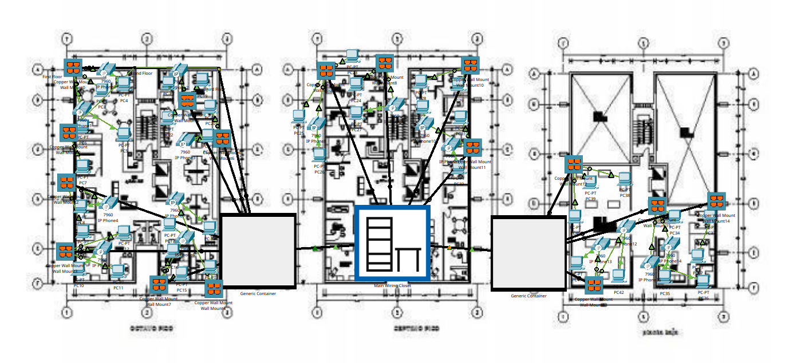
Branch 1 - Mandaue
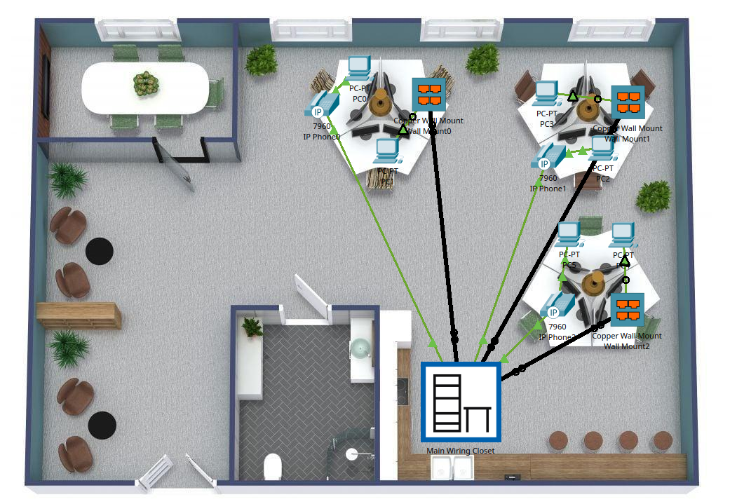
Branch 2 - Lapu-Lapu
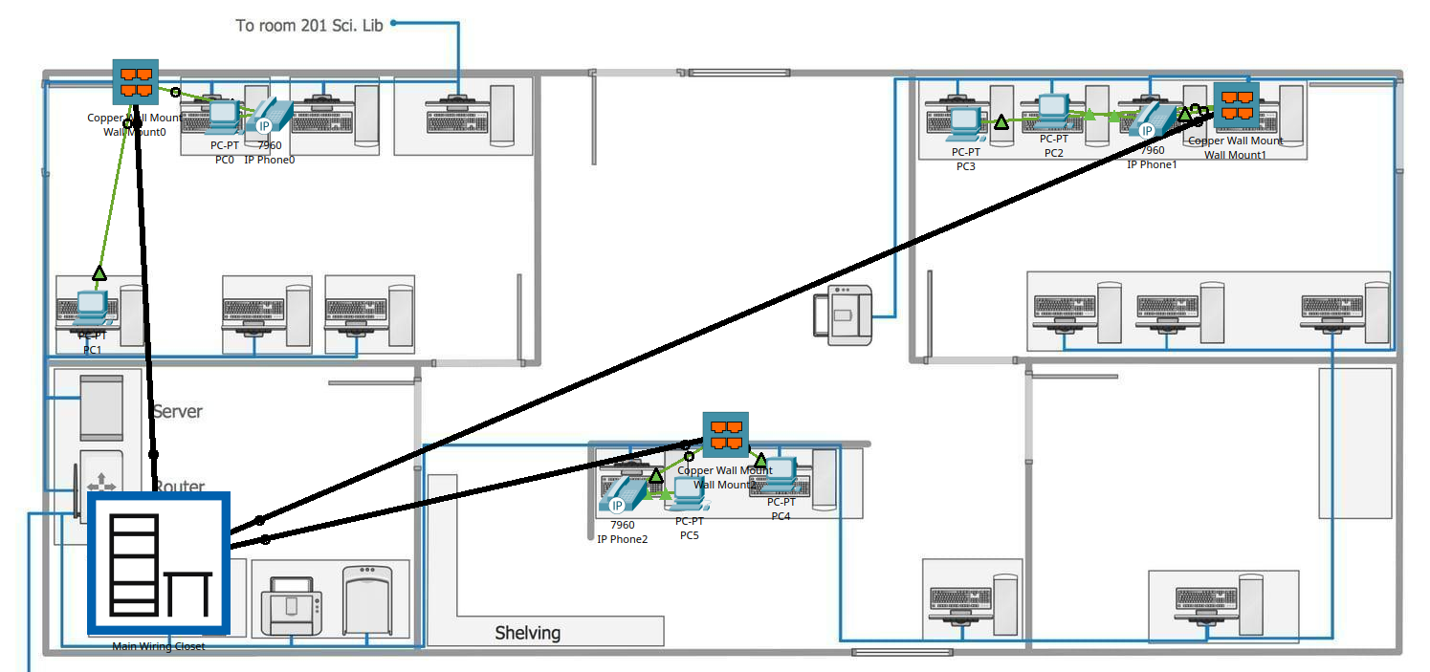
4.3 Network Architecture Design
The architecture follows a hub-and-spoke model that mirrors Kamote Korporation's operational structure. The main headquarters serves as the central hub, with regional depots functioning as secondary hubs for their respective areas, and pickup/drop points connecting as spokes. This hierarchical approach provides efficient resource utilization while maintaining clear communication paths and manageable complexity.

Main Branch Topology
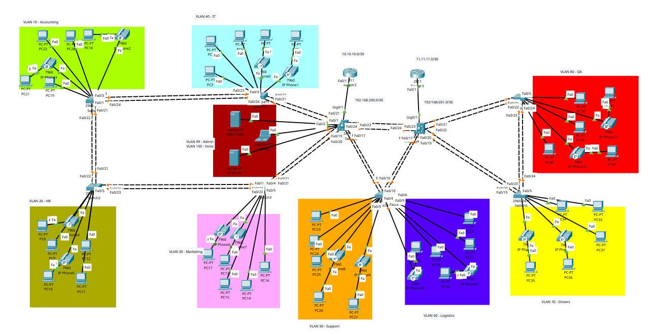
Branch 1 Topology
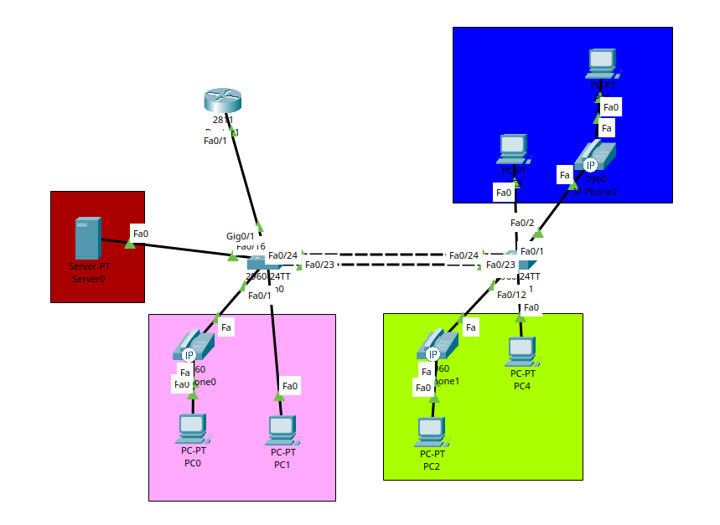
Branch 2 Topology
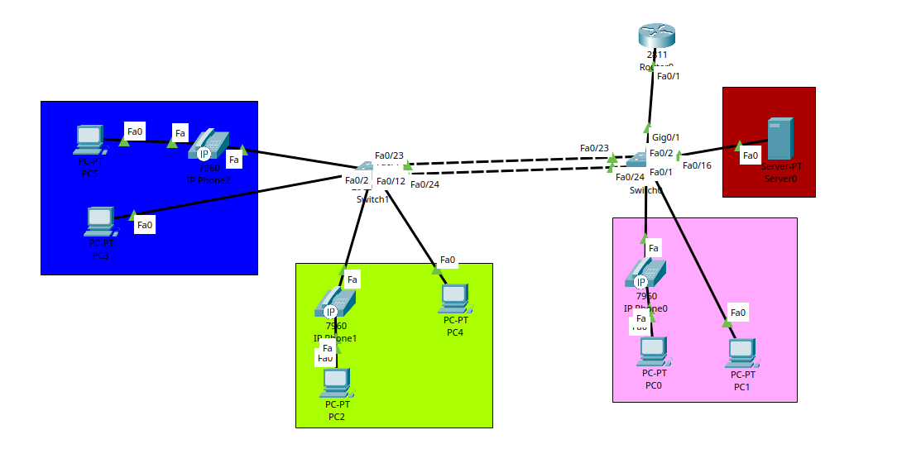

4.4 IP Addressing Strategy
IP address allocation utilized VLSM principles to efficiently distribute address space across locations and departments. The addressing scheme was designed to support current requirements while reserving capacity for expansion into planned locations including Talisay City, Consolacion, and Minglanilla. Each department received appropriately sized subnets based on device counts and anticipated growth, with careful documentation to prevent addressing conflicts during future expansion.

Main Branch
Department | IP
Accounting | 192.168.10.0/24
HR | 192.168.20.0/24
Marketing | 192.168.30.0/24
IT | 192.168.40.0/24
Support | 192.168.50.0/24
Logistics | 192.168.60.0/24
Drivers | 192.168.70.0/24
QA | 192.168.80.0/24
Admin | 192.168.99.0/24
Voice | 192.168.150.0/24

Branch 1 - Mandaue
Department | IP
Accounting | 100.100.10.0/24
HR | 100.100.20.0/24
Marketing | 100.100.30.0/24
Admin | 100.100.99.0/24
Voice | 100.100.150.0/24

Branch 2 - Lapu-Lapu
Department | IP
Accounting | 200.200.10.0/24
HR | 200.200.20.0/24
Marketing | 200.200.30.0/24
Admin | 200.200.99.0/24
Voice | 200.200.150.0/24

4.5 VLAN Segmentation
VLANs were assigned to separate departmental traffic logically across the organization. Each major department—Dispatch Coordination, Inventory Management, Quality Control, Administration, Accounting, and IT Operations—received dedicated VLANs. This segmentation improves both network performance and security by containing broadcast traffic and enabling granular access control policies. A separate management VLAN was designated for network device administration, and voice VLANs were allocated for IP telephony implementation.
Main Branch
Department | VLAN
Accounting | 10
HR | 20
Marketing | 30
IT | 40
Support | 50
Logistics | 60
Drivers | 70
QA | 80
Admin | 99
Voice | 150

Branch 1 - Mandaue
Department | VLAN
Accounting | 10
HR | 20
Marketing | 30
Admin | 99
Voice | 150

Branch 2 - Lapu-Lapu
Department | VLAN
Accounting | 10
HR | 20
Marketing | 30
Admin | 99
Voice | 150

4.6 Routing Protocol Selection
The routing design implements a dual-protocol approach. OSPF handles internal routing within the main headquarters, providing efficient path selection across the multi-floor facility with its eight departments. EIGRP manages inter-branch routing, connecting the main headquarters with regional depots and pickup/drop points. This combination leverages OSPF's strengths for complex internal routing while utilizing EIGRP's efficiency for wide-area connectivity. In order for these two protocols to work and for the branches to communicate, redistribution is also apple.
Branch | Routing Protocol
Main Branch | OSPF
Branch 1 - Mandaue | EIGRP
Branch 2 - Lapu-Lapu | EIGRP

4.7 Redundancy Implementation
Redundancy mechanisms were integrated throughout the design. The main headquarters connects to dual ISPs (PLDT and Globe) to ensure continuous external connectivity. EtherChannel link aggregation provides redundant inter-switch connections, maintaining network operation even if individual links fail. Multiple Layer 3 routing paths ensure traffic can reach destinations through alternate routes if primary paths become unavailable through HSRP.
4.8 Voice Communication Infrastructure
IP telephony implementation enables voice communications over the existing data network infrastructure. Each department receives IP phones according to operational requirements: two phones per office in most locations, with adjustments based on departmental size and communication needs. The voice network utilizes dedicated VLANs to ensure quality of service for voice traffic, maintaining call quality even during high data usage periods.
Phone Number Scheme
Branch | Numbering Scheme
Main Branch | 10xx
Branch 1 - Mandaue | 11x0
Branch 2 - Lapu-Lapu | 12x0

4.9 Security Measures
Layer 2 security features protect network access at the switch level. Port security restricts which devices can connect to network ports based on MAC addresses. Authentication mechanisms control access to network devices, ensuring only authorized personnel can make configuration changes. Access control lists could be implemented to further restrict traffic flow between VLANs based on organizational security policies.
4.10 Network Services Configuration
Essential network services support operational requirements across all locations. DHCP servers automate IP address assignment, eliminating manual configuration overhead and reducing configuration errors. DNS services enable name-based resource access rather than requiring users to remember IP addresses. FTP servers facilitate file sharing between branches for operational documents and reports. Email services support internal communications, and web services provide access to organizational resources.
4.11 Simulation and Testing
Cisco Packet Tracer served as the primary simulation environment for design validation. The complete network topology was constructed virtually, including all routers, switches, computers, and IP phones across the main headquarters and branch locations.
4.12 Configuration Development
Network device configurations were developed systematically, beginning with basic connectivity and progressing through advanced features. Router configurations established IP addressing on interfaces, configured routing protocols, and implemented inter-VLAN routing. Switch configurations created VLANs, assigned ports to appropriate VLANs, configured trunk links, and implemented EtherChannel port aggregation. IP phone configurations integrated voice communications into the network infrastructure.
4.13 Testing Procedures
Comprehensive testing verified that all design requirements were met. Connectivity testing confirmed that devices within departments could communicate appropriately, inter-department communications functioned according to design, and branch locations could reach the main headquarters and other branches. Routing protocol operation was verified to ensure proper route learning and convergence. IP telephony testing confirmed voice communications functioned across all locations. Redundancy testing validated that backup paths activated when primary links failed.
4.14 Documentation

Throughout the design and simulation process, comprehensive documentation captured all design decisions, addressing schemes, VLAN assignments, configuration files, and testing results. This documentation provides the foundation for eventual physical implementation and serves as reference material for network management and troubleshooting.
The methodology employed ensures that Kamote Korporation's network infrastructure design is systematic, comprehensive, and aligned with operational requirements. The structured approach provides confidence that the design will support current needs while accommodating future organizational growth.
CHAPTER V
DISCUSSION AND IMPLEMENTATION
This chapter discusses the practical implementation of Kamote Korporation's network infrastructure design, explaining how technical concepts translate into a functional multi-branch communication system. The implementation demonstrates how planning and methodology result in operational network capabilities that support the organization's agricultural logistics operations.
5.1 Network Infrastructure Overview
The implemented network infrastructure creates a unified communication platform connecting Kamote Korporation's main headquarters in Cebu City with regional depots in Mandaue and Lapu-Lapu, as well as multiple pickup/drop points across the service area. The design accommodates current operational requirements while providing the scalability necessary for planned expansion into additional municipalities.
Hierarchical Network Design
The implementation follows a three-tier hierarchical model adapted to Kamote Korporation's organizational structure. The core tier, located at the main headquarters, provides high-speed backbone connectivity and inter-VLAN routing capabilities. The distribution tier, represented by regional depot networks, aggregates connections from local departments and facilitates communication with the core. The access tier, including switches at all locations, provides direct connectivity for end-user devices including computers, IP phones, and other network-enabled equipment.
Main Headquarters Implementation
The main headquarters network supports eight departments across a multi-floor facility. Each department operates within dedicated VLANs, with inter-VLAN routing provided by Layer 3 switches or router-on-a-stick configuration depending on equipment capabilities. The headquarters hosts critical network services including DHCP servers, DNS servers, FTP file sharing, email services, and IP telephony call managers. Redundant routers provide dual ISP connectivity to both PLDT and Globe, ensuring continuous external communications.
Regional Depot Networks
The Mandaue and Lapu-Lapu depot networks implement scaled versions of the headquarters design, supporting their respective departments with VLAN segmentation and local network services. Each depot maintains local DHCP services for automatic device configuration and connects to the main headquarters through dedicated WAN links. Routing protocols ensure that inter-branch communications follow optimal paths while maintaining alternate routes for redundancy.
Pickup/Drop Point Connectivity
Smaller pickup/drop points implement simplified network configurations appropriate to their operational scope. These locations connect to the nearest regional depot or directly to the main headquarters, depending on geographical and operational considerations. Even at these smaller locations, IP telephony enables seamless voice communications with all other organizational facilities.
5.2 IP Addressing and VLAN Implementation
The IP addressing scheme organizes network resources logically, with address ranges allocated to support current needs and future expansion. VLSM techniques ensure efficient address utilization, with subnet sizes matched to departmental device counts. Documentation of address assignments prevents conflicts and facilitates troubleshooting.
VLAN implementation segments network traffic according to organizational structure and functional requirements. Departmental VLANs separate traffic by business function, management VLANs isolate network device administration, and voice VLANs prioritize IP telephony communications. Trunk links between switches carry multiple VLANs simultaneously, with proper tagging ensuring traffic reaches intended destinations.
5.3 Routing Protocol Configuration
OSPF configuration within the main headquarters creates a dynamic routing environment that adapts to topology changes. Routers and Layer 3 switches exchange routing information, building complete network maps and calculating optimal paths to all destinations. The protocol's fast convergence ensures minimal disruption if network links fail or topology changes occur.
EIGRP configuration manages inter-branch routing, connecting geographically dispersed locations through the ISP networks. Route redistribution between OSPF and EIGRP at boundary points ensures seamless communication between headquarters internal networks and branch locations. The dual-protocol approach optimizes routing for different network segments while maintaining organizational connectivity.
5.4 Redundancy and High Availability
Multiple redundancy mechanisms ensure network reliability. Dual ISP connections provide external connectivity redundancy. EtherChannel link aggregation bundles multiple physical connections between switches, providing both increased bandwidth and automatic failover if individual links fail. Multiple routing paths ensure that traffic can reach destinations through alternate routes if primary paths become unavailable.
5.5 IP Telephony Deployment
IP telephony implementation replaces traditional phone systems with voice-over-IP communications. IP phones connect to network switches configured with voice VLANs, ensuring quality of service for voice traffic. Inter-branch calls traverse the same network infrastructure that carries data traffic, eliminating separate phone line expenses while providing superior functionality.
Each office location receives IP phones according to operational requirements. The main headquarters departments receive two phones per office, ensuring adequate communication capacity. Branch locations and pickup/drop points receive appropriate phone allocations based on their operational scope and staff counts.
5.6 Network Services Integration
DHCP services automate IP address assignment across all locations. Servers at the main headquarters and regional depots provide address pools for their respective locations, eliminating manual device configuration and reducing errors. DNS services enable name-based resource access, allowing employees to access network resources using intuitive names rather than numeric IP addresses.
File transfer capabilities via FTP support operational workflows requiring document and data sharing between locations. Quality control reports, dispatch schedules, inventory records, and other operational data can be efficiently transferred between facilities. Email services facilitate internal communications, with SMTP servers handling message delivery across the organization.
5.7 Security Implementation
Layer 2 security features protect network access. Port security on switches prevents unauthorized devices from connecting to the network by restricting access based on MAC addresses. If an unknown device attempts to connect, the switch port can be automatically disabled, preventing potential security breaches.
Access control to network devices themselves prevents unauthorized configuration changes. Console and VTY line access requires authentication, ensuring only authorized IT personnel can modify network settings. Different privilege levels could be implemented to provide appropriate access for different administrative roles.
5.8 Testing and Validation
Comprehensive testing validated all aspects of the implementation. Connectivity tests confirmed that devices could communicate within their VLANs, across VLANs when appropriate, and between locations. Routing protocol operation was verified by examining routing tables and observing how routes change when links fail. IP telephony testing confirmed voice quality and call completion rates across all locations.
Redundancy testing deliberately failed primary links and connections to verify that backup mechanisms activated properly. These tests demonstrated that the network maintains operation even when individual components fail, providing the reliability necessary for business-critical communications.
5.9 Operational Benefits
The implemented infrastructure addresses the operational challenges identified in Chapter I. Unified voice communications eliminate the fragmentation of personal mobile devices and disparate communication channels. Real-time coordination between dispatch, inventory management, and quality control departments improves operational efficiency. Cost management benefits accrue from eliminating per-location telecommunications service contracts in favor of organizational infrastructure. Scalability is built into the design, enabling new locations to be added without fundamental architectural changes.
The network infrastructure becomes an operational asset that enables better business processes rather than simply providing basic connectivity. The integration of voice, data, and network services creates a platform that supports current operations while enabling future capabilities as the organization evolves.
CHAPTER VI
CONCLUSION AND RECOMMENDATION
This final chapter synthesizes the findings from the network infrastructure design project for Kamote Korporation and provides recommendations for moving forward with implementation and future development.
6.1 Conclusion
This project successfully designed a comprehensive multi-branch network infrastructure that addresses Kamote Korporation's communication and connectivity requirements. The design provides unified voice communications, data networking capabilities, and essential network services across the main headquarters, regional depots, and pickup/drop points throughout the organization's service area.
Achievement of Project Objectives
The project fulfilled its stated objectives by creating an integrated infrastructure that supports seamless communication across all organizational facilities. The design establishes voice communication capabilities connecting the main headquarters with all regional locations, supports departmental workflows through appropriate VLAN segmentation and network services, and incorporates scalability to accommodate planned expansion without requiring fundamental redesign.
The infrastructure design addresses the operational challenges identified at the project's outset. Inter-branch communication delays are eliminated through unified IP telephony. Operational coordination inefficiencies are reduced through properly segmented network architecture that supports real-time information exchange. Cost management concerns are addressed by consolidating communications onto organizational infrastructure rather than depending on external telecommunications services. Customer service capabilities are enhanced through consistent communication infrastructure across all locations. Scalability constraints are resolved through thoughtful architecture that accommodates growth.
Technical Implementation Validation
The Cisco Packet Tracer simulation demonstrated that the designed network functions as intended. All connectivity requirements were met, routing protocols operated correctly, IP telephony provided voice communications across locations, redundancy mechanisms activated when primary paths failed, and network services supported operational workflows. The simulation provides confidence that physical implementation following the documented design will yield a functional network infrastructure.
Alignment with Industry Best Practices
The design incorporates established networking best practices identified in the literature review. VLAN segmentation improves both performance and security. Redundancy mechanisms protect against single points of failure. Hierarchical network architecture provides clear traffic flows and manageable complexity. Standards-based protocols ensure long-term supportability and vendor flexibility. Security features protect organizational resources and information.
Applicability to Agricultural Logistics Context
The infrastructure design specifically addresses the unique requirements of agricultural logistics operations. Time-sensitive coordination between collection points, depots, and distribution channels is supported through reliable, low-latency voice communications. Quality control workflows benefit from integrated file sharing and communication capabilities. Dispatch coordination is enhanced through seamless inter-facility communications. The infrastructure provides the communication platform necessary for efficient perishable goods logistics.
6.2 Recommendations
Based on the design work completed and lessons learned during the project, several recommendations emerge for Kamote Korporation's consideration as they move toward physical implementation.
Implementation Phasing
Physical implementation should follow a phased approach rather than attempting simultaneous deployment across all locations. Beginning with the main headquarters allows the IT team to gain experience with the infrastructure in a controlled environment before extending to branch locations. Once headquarters implementation stabilizes, regional depots can be brought online, followed by pickup/drop points. This phased approach reduces risk and allows course corrections based on early experiences.
Infrastructure Investment Priorities
Within the overall design, certain components should receive priority during physical implementation. Core routing and switching infrastructure forms the foundation upon which everything else depends and should be implemented first with quality equipment. IP telephony can follow once basic data networking stabilizes, providing immediate operational benefits. Advanced features like comprehensive security policies, detailed quality-of-service configurations, and network monitoring systems can be implemented iteratively as the basic infrastructure proves stable.
Staff Training and Change Management
Technical infrastructure alone does not guarantee operational success. Staff training should address both technical aspects (for IT personnel who will manage the infrastructure) and usage aspects (for employees who will utilize IP phones, network services, and other capabilities). Change management processes should help employees transition from current communication methods to the new unified infrastructure. Clear documentation, responsive support, and patience during the adjustment period will facilitate successful adoption.
Documentation and Ongoing Management
Comprehensive documentation should accompany physical implementation. Network diagrams, IP address assignments, VLAN configurations, device configuration files, and troubleshooting procedures should be maintained in accessible formats. Regular documentation updates as the network evolves ensure that information remains accurate and useful. Establishing documentation standards early prevents the fragmentation that makes network management difficult as infrastructure grows.
Monitoring and Performance Management
Once implemented, the network infrastructure should be actively monitored rather than simply assumed to work. Network monitoring tools can track performance metrics, identify potential issues before they impact operations, and provide data for capacity planning. Regular performance reviews help ensure the network continues to meet organizational requirements as usage patterns evolve.
Security Policy Development
While the design includes security features, comprehensive organizational security policies should be developed to govern network usage. Acceptable use policies, access control policies, password management standards, and incident response procedures should be formalized. Regular security reviews can identify vulnerabilities and ensure security measures remain effective as threats evolve.
Planning for Continued Growth
The network design accommodates planned expansion into Talisay City, Consolacion, and Minglanilla, but Kamote Korporation's growth may extend beyond these initial expansion targets. Regular capacity reviews should assess whether the infrastructure continues to meet organizational needs. Address space management should prevent exhaustion of allocated IP ranges. Equipment refresh cycles should be planned to replace aging hardware before failures disrupt operations.
Vendor Relationships and Support
Establishing relationships with reliable vendors for networking equipment, ISP services, and technical support will facilitate smooth implementation and ongoing operations. Equipment standardization where practical simplifies management and support. Maintenance contracts for critical infrastructure components provide access to vendor technical support when complex issues arise.

Continuous Improvement
The network infrastructure should be viewed as a living system that evolves with organizational needs rather than a fixed installation. Regular reviews should assess whether the infrastructure continues to serve organizational objectives effectively. Emerging technologies should be evaluated for potential application. Employee feedback should inform infrastructure improvements that enhance operational effectiveness.
6.3 Final Remarks
This project demonstrates that comprehensive network infrastructure design is achievable for small-to-medium agricultural logistics enterprises operating in resource-constrained environments. Kamote Korporation's multi-branch communication challenges can be effectively addressed through thoughtful application of established networking technologies and design principles.
The designed infrastructure provides more than basic connectivity—it creates an operational platform that enables efficient coordination across distributed facilities, supports quality customer service, and accommodates organizational growth. By addressing both current operational needs and future scalability requirements, the design represents a strategic investment in organizational capability rather than simply a tactical response to immediate communication challenges.
The project contributes to the broader understanding of how communication infrastructure design principles apply specifically to agricultural logistics contexts in developing economy environments. The documented design decisions, implementation approaches, and lessons learned provide reference material for similar organizations facing comparable challenges.
Kamote Korporation's commitment to comprehensive infrastructure planning positions the organization well for continued growth and operational success in the competitive agricultural logistics sector. The network infrastructure designed in this project provides the communication foundation necessary to maintain operational cohesion as the organization scales to serve additional communities and markets across the region.

REFERENCES
Anderson, M., & Davis, R. (2021). Hub-and-spoke distribution models: Communication
infrastructure requirements and failure modes. Journal of Operations Management, 45(3), 312-329.
Baker, J., & Thompson, L. (2020). Security considerations in organizational communication
infrastructure. Information Systems Security Review, 28(2), 156-174.
Chandler, A., & Mazlish, B. (2017). Managing distributed organizations: Infrastructure and
coordination mechanisms. Harvard Business Review, 92(4), 88-102.
Chen, Y., & Williams, P. (2021). Economic analysis of unified communication platforms in
multi-location enterprises. International Journal of Business Technology, 15(1), 45-63.
Davenport, T., & Harris, J. (2020). Competing on analytics: Infrastructure integration for
organizational effectiveness. MIT Press.
Garcia, M., & Martinez, R. (2020). Regulatory frameworks for organizational telecommunications
in Southeast Asia. Asian Business Law Review, 33(2), 201-219.
Gomez, A., & Reyes, M. (2021). Telecommunications compliance requirements for Philippine
businesses: A practical guide. Philippine Journal of Business Administration, 18(3), 122-140.
International Logistics Association. (2020). Global logistics efficiency benchmarks: The role of
communication infrastructure. Annual Industry Report.
International Telecommunications Union. (2019). Quality of service standards for organizational
voice communications. ITU Technical Standard G.1010.
Johnson, K., & Lee, S. (2021). Communication platforms as organizational enablers: Integration
patterns and business value. Strategic Management Journal, 38(4), 567-585.
Kaplan, R., & Norton, D. (2018). The balanced scorecard approach to infrastructure investment
decisions. Harvard Business School Press.
Kumar, S., & Bhattacharya, R. (2020). Impact of unified communication systems on SME
operational efficiency: A quantitative analysis. Journal of Small Business Management, 58(2), 234-256.
Kumar, V., & Patel, N. (2020). Infrastructure investment timing and organizational growth
trajectories in emerging markets. Emerging Markets Review, 42, 156-173.
Lee, H., & Park, J. (2021). Security frameworks for small and medium enterprise communication
infrastructure. Computers & Security, 98, 102-118.
Martinez, C., & Santos, R. (2019). Integration benefits in agricultural logistics: Communication
and inventory systems. Supply Chain Management Review, 23(4), 78-94.
Mentzer, J., DeWitt, W., Keebler, J., Min, S., Nix, N., Smith, C., & Zacharia, Z. (2019). Defining
supply chain management and the role of real-time communication. Journal of Business Logistics, 40(2), 25-45.
Miller, T., & Harrison, S. (2019). Total cost of ownership models for organizational
communication infrastructure. Journal of Information Technology Management, 30(3), 189-207.
Mitchell, R., & Brown, D. (2019). Standards-based infrastructure: Vendor flexibility and long-term
organizational value. Technology Management Review, 44(1), 34-52.
Morrison, P., & Davis, K. (2021). Beyond ROI: Comprehensive frameworks for evaluating
communication infrastructure investments. Business Value Assessment Journal, 17(2), 98-116.
Nguyen, T., & Tran, L. (2021). Communication infrastructure challenges in Southeast Asian
agricultural SMEs. Asian Agricultural Business Review, 29(3), 145-162.
Patel, S., & Charoensuk, W. (2021). Infrastructure transformation in Thai perishable goods
logistics: A case study analysis. Logistics Research Quarterly, 26(2), 201-223.
Porter, M., & Thompson, J. (2020). Scalability in organizational infrastructure: Design principles
for growing enterprises. California Management Review, 62(3), 67-89.
Rahman, M., & Ahmad, F. (2020). Multi-location communication infrastructure implementation: A
Malaysian distribution enterprise case study. Malaysian Business Review, 35(4), 312-334.
Reyes, J., & Santos, E. (2019). Rural agricultural cooperative communication systems: A
Philippine implementation case study. Philippine Agricultural Economics Review, 22(1), 56-78.
Rogers, E. (2019). Diffusion of innovations (6th ed.). Free Press.
Santos, L., & Lim, R. (2020). Technology adoption patterns in Philippine SMEs: Success factors
and common challenges. Philippine Management Review, 27(2), 89-107.
Santos, M., & Rodriguez, A. (2019). Time-sensitive coordination in perishable goods distribution:
Communication infrastructure requirements. International Journal of Physical Distribution & Logistics Management, 49(8), 823-841.
Stevens, P., & Martinez, D. (2018). Voice communication quality requirements for business
operations. Communications Technology Journal, 52(3), 178-196.
Thompson, R., & Kumar, A. (2020). Communication quality impacts on logistics operational
accuracy. Transportation Research Part E, 137, 101-119.
Turban, E., Pollard, C., & Wood, G. (2018). Information technology for management: Advancing
sustainable, profitable business growth (11th ed.). Wiley.
Williams, C., & Chen, L. (2020). Communication infrastructure and product quality preservation
in perishable goods supply chains. Journal of Food Distribution Research, 51(2), 45-67.
Wilson, D., & Chen, M. (2019). Business continuity planning for communication-dependent
operations. Risk Management Review, 41(4), 234-251.
Zhang, L., & Wang, H. (2021). Interoperability considerations in organizational infrastructure
planning. Enterprise Architecture Journal, 19(1), 67-84.

APPENDICES
APPENDIX A: Floor Plan and Structured Cabling
Main Branch
Branch 1 - Mandaue
Branch 2 - Lapu-Lapu
APPENDIX B: Topology
Main Branch Topology
Branch 1 Topology
Branch 2 Topology

APPENDIX C: Configurations

Multilayer Switch Configuration
Current configuration : 7318 bytes
!
version 12.2(37)SE1
no service timestamps log datetime msec
no service timestamps debug datetime msec
service password-encryption
!
hostname MultilayerSwitch1
!
!
no profinet
enable secret 5 $1$mERr$hx5rVt7rPNoS4wqbXKX7m0
!
!
!
!
!
ip routing
!
!
!
!
username admin secret 5 $1$mERr$hx5rVt7rPNoS4wqbXKX7m0
!
!
!
!
!
!
!
!
!
!
ip ssh version 2
ip domain-name cisco.com
!
!
spanning-tree mode pvst
!
!
!
!
!
!
interface Port-channel1
switchport trunk native vlan 99
switchport trunk allowed vlan 1-1000
switchport trunk encapsulation dot1q
switchport mode trunk
!
interface Port-channel2
switchport trunk native vlan 99
switchport trunk allowed vlan 1-1000
switchport trunk encapsulation dot1q
switchport mode trunk
!
interface Port-channel3
switchport trunk native vlan 99
switchport trunk allowed vlan 1-1000
switchport trunk encapsulation dot1q
switchport mode trunk
!
interface Port-channel4
switchport trunk native vlan 99
switchport trunk allowed vlan 1-1000
switchport trunk encapsulation dot1q
switchport mode trunk
!
interface FastEthernet0/1
no switchport
no ip address
ip ospf 1 area 0
duplex auto
speed auto
!
interface FastEthernet0/2
switchport access vlan 99
switchport mode access
switchport port-security
switchport port-security maximum 5
switchport port-security mac-address sticky
switchport port-security mac-address sticky 00E0.A360.4A3E
!
interface FastEthernet0/3
switchport access vlan 99
switchport mode access
switchport port-security
switchport port-security maximum 5
switchport port-security mac-address sticky
switchport port-security mac-address sticky 0001.639C.75A0
!
interface FastEthernet0/4
shutdown
!
interface FastEthernet0/5
shutdown
!
interface FastEthernet0/6
shutdown
!
interface FastEthernet0/7
shutdown
!
interface FastEthernet0/8
shutdown
!
interface FastEthernet0/9
shutdown
!
interface FastEthernet0/10
shutdown
!
interface FastEthernet0/11
shutdown
!
interface FastEthernet0/12
shutdown
!
interface FastEthernet0/13
shutdown
!
interface FastEthernet0/14
shutdown
!
interface FastEthernet0/15
shutdown
!
interface FastEthernet0/16
switchport trunk native vlan 99
switchport trunk allowed vlan 1-1000
shutdown
!
interface FastEthernet0/17
switchport trunk native vlan 99
switchport trunk allowed vlan 1-1000
switchport trunk encapsulation dot1q
switchport mode trunk
channel-group 4 mode active
!
interface FastEthernet0/18
switchport trunk native vlan 99
switchport trunk allowed vlan 1-1000
switchport trunk encapsulation dot1q
switchport mode trunk
channel-group 4 mode active
!
interface FastEthernet0/19
switchport trunk native vlan 99
switchport trunk allowed vlan 1-1000
switchport trunk encapsulation dot1q
switchport mode trunk
channel-group 3 mode active
!
interface FastEthernet0/20
switchport trunk native vlan 99
switchport trunk allowed vlan 1-1000
switchport trunk encapsulation dot1q
switchport mode trunk
channel-group 3 mode active
!
interface FastEthernet0/21
switchport trunk native vlan 99
switchport trunk allowed vlan 1-1000
switchport trunk encapsulation dot1q
switchport mode trunk
channel-group 2 mode active
!
interface FastEthernet0/22
switchport trunk native vlan 99
switchport trunk allowed vlan 1-1000
switchport trunk encapsulation dot1q
switchport mode trunk
channel-group 2 mode active
!
interface FastEthernet0/23
switchport trunk native vlan 99
switchport trunk allowed vlan 1-1000
switchport trunk encapsulation dot1q
switchport mode trunk
channel-group 1 mode active
!
interface FastEthernet0/24
switchport trunk native vlan 99
switchport trunk allowed vlan 1-1000
switchport trunk encapsulation dot1q
switchport mode trunk
channel-group 1 mode active
!
interface GigabitEthernet0/1
description Connection to EdgeRouter1 (PLDT)
no switchport
ip address 192.168.200.1 255.255.255.252
duplex auto
speed auto
!
interface GigabitEthernet0/2
shutdown
!
interface Vlan1
no ip address
shutdown
!
interface Vlan10
description VLAN 10 - Area 1
mac-address 0090.2169.5001
ip address 192.168.10.2 255.255.255.0
ip helper-address 192.168.99.4
ip ospf 1 area 1
standby version 2
standby 10 ip 192.168.10.1
standby 10 priority 110
standby 10 preempt
!
interface Vlan20
description VLAN 20 - Area 1
mac-address 0090.2169.5002
ip address 192.168.20.2 255.255.255.0
ip helper-address 192.168.99.4
ip ospf 1 area 1
standby version 2
standby 20 ip 192.168.20.1
standby 20 priority 110
standby 20 preempt
!
interface Vlan30
description VLAN 30 - Area 1
mac-address 0090.2169.5003
ip address 192.168.30.2 255.255.255.0
ip helper-address 192.168.99.4
ip ospf 1 area 1
standby version 2
standby 30 ip 192.168.30.1
standby 30 priority 110
standby 30 preempt
!
interface Vlan40
description VLAN 40 - Area 1
mac-address 0090.2169.5004
ip address 192.168.40.2 255.255.255.0
ip helper-address 192.168.99.4
ip ospf 1 area 1
standby version 2
standby 40 ip 192.168.40.1
standby 40 priority 110
standby 40 preempt
!
interface Vlan50
description VLAN 50 - Area 2
mac-address 0090.2169.5005
ip address 192.168.50.2 255.255.255.0
ip helper-address 192.168.99.4
ip ospf 1 area 2
standby version 2
standby 50 ip 192.168.50.1
standby 50 priority 110
standby 50 preempt
!
interface Vlan60
description VLAN 60 - Area 2
mac-address 0090.2169.5006
ip address 192.168.60.2 255.255.255.0
ip helper-address 192.168.99.4
ip ospf 1 area 2
standby version 2
standby 60 ip 192.168.60.1
standby 60 priority 110
standby 60 preempt
!
interface Vlan70
description VLAN 70 - Area 3
mac-address 0090.2169.5007
ip address 192.168.70.2 255.255.255.0
ip helper-address 192.168.99.4
ip ospf 1 area 3
standby version 2
standby 70 ip 192.168.70.1
standby 70 priority 110
standby 70 preempt
!
interface Vlan80
description VLAN 80 - Area 3
mac-address 0090.2169.5008
ip address 192.168.80.2 255.255.255.0
ip helper-address 192.168.99.4
ip ospf 1 area 3
standby version 2
standby 80 ip 192.168.80.1
standby 80 priority 110
standby 80 preempt
!
interface Vlan99
description VLAN 99 - Area 0 Backbone
mac-address 0090.2169.5009
ip address 192.168.99.2 255.255.255.0
ip ospf 1 area 0
standby version 2
standby 99 ip 192.168.99.1
standby 99 priority 110
standby 99 preempt
!
interface Vlan150
description VLAN 150 - Area 0 Backbone
mac-address 0090.2169.500a
ip address 192.168.150.2 255.255.255.0
ip helper-address 192.168.200.2
ip ospf 1 area 0
standby version 2
standby 150 ip 192.168.150.1
standby 150 priority 110
standby 150 preempt
!
router ospf 1
router-id 1.1.1.1
log-adjacency-changes
network 192.168.99.0 0.0.0.255 area 0
network 192.168.150.0 0.0.0.255 area 0
network 192.168.200.0 0.0.0.3 area 0
network 192.168.10.0 0.0.0.255 area 1
network 192.168.20.0 0.0.0.255 area 1
network 192.168.30.0 0.0.0.255 area 1
network 192.168.40.0 0.0.0.255 area 1
network 192.168.50.0 0.0.0.255 area 2
network 192.168.60.0 0.0.0.255 area 2
network 192.168.70.0 0.0.0.255 area 3
network 192.168.80.0 0.0.0.255 area 3
!
ip classless
!
ip flow-export version 9
!
!
!
banner motd ^CAuthorized Personnel Only!^C
!
!
!
!
!
line con 0
password 7 0822455D0A16
login
!
line aux 0
!
line vty 0 4
password 7 0822455D0A16
login
transport input telnet
line vty 5 15
login local
transport input ssh
!
!
!
!
end

Edge Router Configuration
Current configuration : 3717 bytes
!
version 15.1
no service timestamps log datetime msec
no service timestamps debug datetime msec
service password-encryption
!
hostname EdgeRouter1
!
!
!
enable secret 5 $1$mERr$hx5rVt7rPNoS4wqbXKX7m0
!
!
ip dhcp excluded-address 192.168.150.1 192.168.150.10
!
ip dhcp pool Voice
network 192.168.150.0 255.255.255.0
default-router 192.168.150.1
option 150 ip 192.168.200.2
!
!
!
ip cef
no ipv6 cef
!
!
!
username admin secret 5 $1$mERr$hx5rVt7rPNoS4wqbXKX7m0
!
!
license udi pid CISCO2811/K9 sn FTX10176676-
!
!
!
!
!
!
!
!
!
!
!
ip ssh version 2
ip domain-name cisco.com
!
!
spanning-tree mode pvst
!
!
!
!
!
!
interface FastEthernet0/0
description Connection to ISP GLOBE
ip address 10.10.10.1 255.255.255.252
duplex auto
speed auto
!
interface FastEthernet0/1
description Connection to MLS1
ip address 192.168.200.2 255.255.255.252
ip ospf 1 area 0
duplex auto
speed auto
!
interface Vlan1
no ip address
shutdown
!
router eigrp 100
redistribute ospf 1 metric 10000 100 255 1 1500
network 10.10.10.0 0.0.0.3
!
router ospf 1
router-id 10.10.10.1
log-adjacency-changes
redistribute eigrp 100 subnets
network 192.168.200.0 0.0.0.3 area 0
default-information originate
!
ip classless
!
ip flow-export version 9
!
!
!
banner motd ^CAuthorized Personnel Only!^C
!
!
!
!
dial-peer voice 100 voip
destination-pattern 11[1-3]0
session target ipv4:100.100.150.1
!
dial-peer voice 200 voip
destination-pattern 12[1-3]0
session target ipv4:200.200.150.1
!
dial-peer voice 1000 voip
destination-pattern 10[1-2].
session target ipv4:192.168.150.1
!
telephony-service
max-ephones 16
max-dn 16
ip source-address 192.168.150.1 port 2000
!
ephone-dn 1
number 1011
!
ephone-dn 2
number 1012
!
ephone-dn 3
number 1013
!
ephone-dn 4
number 1014
!
ephone-dn 5
number 1015
!
ephone-dn 6
number 1016
!
ephone-dn 7
number 1017
!
ephone-dn 8
number 1018
!
ephone-dn 9
number 1019
!
ephone-dn 10
number 1020
!
ephone-dn 11
number 1021
!
ephone-dn 12
number 1022
!
ephone-dn 13
number 1023
!
ephone-dn 14
number 1024
!
ephone-dn 15
number 1025
!
ephone-dn 16
number 1026
!
ephone 1
device-security-mode none
mac-address 0003.E4CA.5374
type 7960
button 1:1
!
ephone 2
device-security-mode none
mac-address 0003.E444.EB07
type 7960
button 1:2
!
ephone 3
device-security-mode none
mac-address 000C.857E.4E40
type 7960
button 1:3
!
ephone 4
device-security-mode none
mac-address 000A.416B.E064
type 7960
button 1:4
!
ephone 5
device-security-mode none
mac-address 00D0.FF45.B3A1
type 7960
button 1:5
!
ephone 6
device-security-mode none
mac-address 0060.2FED.A058
type 7960
button 1:6
!
ephone 7
device-security-mode none
mac-address 0005.5E80.C9CA
type 7960
button 1:7
!
ephone 8
device-security-mode none
mac-address 00D0.FF6C.4554
type 7960
button 1:8
!
ephone 9
device-security-mode none
mac-address 0001.9614.3C1E
type 7960
button 1:9
!
ephone 10
device-security-mode none
mac-address 000D.BDD0.65B1
type 7960
button 1:10
!
ephone 11
device-security-mode none
mac-address 0005.5E2B.64ED
type 7960
button 1:11
!
ephone 12
device-security-mode none
mac-address 0001.C7AA.0D2D
type 7960
button 1:12
!
ephone 13
device-security-mode none
mac-address 0001.6474.6639
type 7960
button 1:13
!
ephone 14
device-security-mode none
mac-address 0001.C737.BE5C
type 7960
button 1:14
!
ephone 15
device-security-mode none
mac-address 00E0.F987.853C
type 7960
button 1:15
!
ephone 16
device-security-mode none
mac-address 0001.C962.E922
type 7960
button 1:16
!
line con 0
password 7 0822455D0A16
login
!
line aux 0
!
line vty 0 4
password 7 0822455D0A16
login
transport input telnet
line vty 5 15
login local
transport input ssh
!
!
!
en

Switch Configuration

Building configuration...
Current configuration : 3685 bytes
!
version 15.0
no service timestamps log datetime msec
no service timestamps debug datetime msec
service password-encryption
!
hostname Switch1
!
enable secret 5 $1$mERr$hx5rVt7rPNoS4wqbXKX7m0
!
!
!
ip ssh version 2
ip domain-name cisco.com
!
username admin secret 5 $1$mERr$hx5rVt7rPNoS4wqbXKX7m0
!
!
!
spanning-tree mode pvst
spanning-tree extend system-id
!
interface Port-channel1
switchport trunk native vlan 99
switchport trunk allowed vlan 1-1000
switchport mode trunk
!
interface Port-channel2
switchport trunk native vlan 99
switchport trunk allowed vlan 1-1000
switchport mode trunk
!
interface FastEthernet0/1
switchport access vlan 10
switchport mode access
switchport voice vlan 150
switchport port-security
switchport port-security maximum 5
switchport port-security mac-address sticky
switchport port-security mac-address sticky 0001.966E.1ED0
switchport port-security mac-address sticky 0001.C7AA.0D2D
!
interface FastEthernet0/2
switchport access vlan 10
switchport mode access
switchport voice vlan 150
switchport port-security
switchport port-security maximum 5
switchport port-security mac-address sticky
switchport port-security mac-address sticky 0004.9A02.9D3D
!
interface FastEthernet0/3
switchport access vlan 10
switchport mode access
switchport voice vlan 150
switchport port-security
switchport port-security maximum 5
switchport port-security mac-address sticky
switchport port-security mac-address sticky 0060.7082.242C
!
interface FastEthernet0/4
switchport access vlan 10
switchport mode access
switchport voice vlan 150
switchport port-security
switchport port-security maximum 5
switchport port-security mac-address sticky
switchport port-security mac-address sticky 0005.5E2B.64ED
switchport port-security mac-address sticky 00E0.A3D7.C8BA
!
interface FastEthernet0/5
switchport access vlan 10
switchport mode access
switchport voice vlan 150
switchport port-security
switchport port-security maximum 5
switchport port-security mac-address sticky
switchport port-security mac-address sticky 0005.5EE6.A942
!
interface FastEthernet0/6
shutdown
!
interface FastEthernet0/7
shutdown
!
interface FastEthernet0/8
shutdown
!
interface FastEthernet0/9
shutdown
!
interface FastEthernet0/10
shutdown
!
interface FastEthernet0/11
shutdown
!
interface FastEthernet0/12
shutdown
!
interface FastEthernet0/13
shutdown
!
interface FastEthernet0/14
shutdown
!
interface FastEthernet0/15
shutdown
!
interface FastEthernet0/16
shutdown
!
interface FastEthernet0/17
shutdown
!
interface FastEthernet0/18
shutdown
!
interface FastEthernet0/19
shutdown
!
interface FastEthernet0/20
shutdown
!
interface FastEthernet0/21
switchport trunk native vlan 99
switchport trunk allowed vlan 1-1000
switchport mode trunk
channel-group 2 mode active
!
interface FastEthernet0/22
switchport trunk native vlan 99
switchport trunk allowed vlan 1-1000
switchport mode trunk
channel-group 2 mode active
!
interface FastEthernet0/23
switchport trunk native vlan 99
switchport trunk allowed vlan 1-1000
switchport mode trunk
channel-group 1 mode active
!
interface FastEthernet0/24
switchport trunk native vlan 99
switchport trunk allowed vlan 1-1000
switchport mode trunk
channel-group 1 mode active
!
interface GigabitEthernet0/1
shutdown
!
interface GigabitEthernet0/2
shutdown
!
interface Vlan1
no ip address
shutdown
!
interface Vlan99
ip address 192.168.99.6 255.255.255.0
!
banner motd ^CAuthorized Personnel Only!^C
!
!
!
line con 0
password 7 0822455D0A16
login
!
line vty 0 4
password 7 0822455D0A16
login
transport input telnet
line vty 5 15
login local
transport input ssh
!
!
!
!
end

